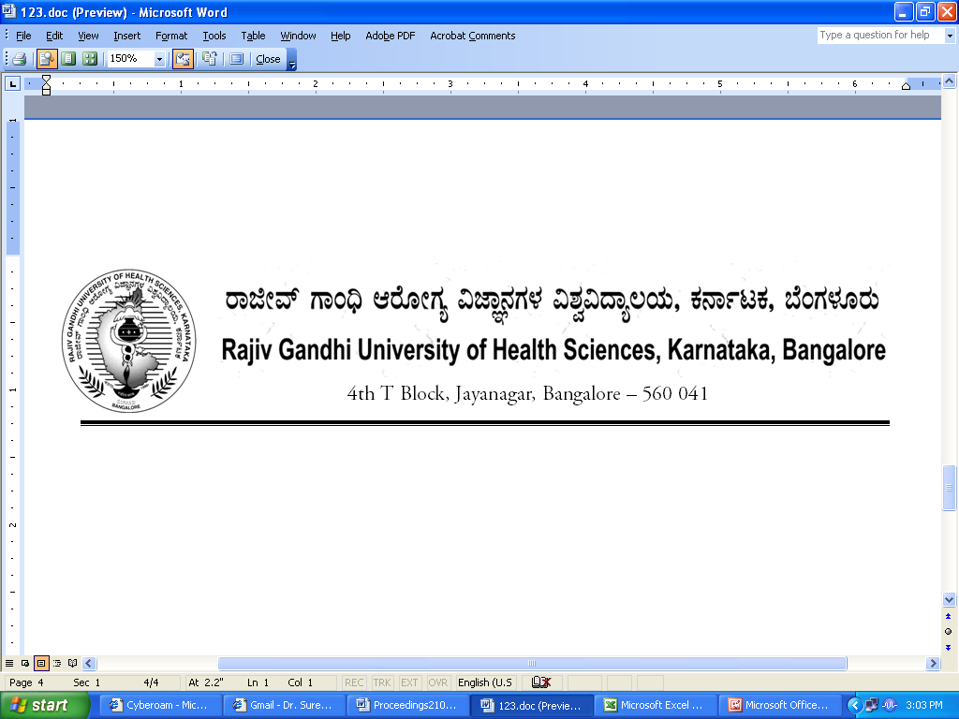
Reg(E)Exam/SPL/December- 2017 Date: 25/09/2017

Advance Notification

Conduct of Super Specialty Course Supplementary Examination during December - 2017.
********

The Super Specialty Supplementary Examination for the below mentioned courses will tentatively commence from 12th December- 2017. The detailed Time Table will be notified in due course.

1. | Super specialty | 12th December, 2017

The Principals of the concerned Colleges are requested to notify this on the Notice Board of their colleges for information of the students concerned.

Sd/-

Registrar (Evaluation)
To:
All the Principals of the colleges concerned for information and needful action.

Copy to:

- PA to Vice-Chancellor/Registrar/Finance Officer, RGUHS, Bangalore.
- Deputy Registrar (Admn) section for information and needful action.
- All the officers of the RGUHS, Bangalore.
- Asst. Registrar, Regional Center, Belgaum / Gulbarga.
- Guard File.

Note: Kindly send the panel of examiners for Super Specialty Course

